Creative writing students find inspiration in France
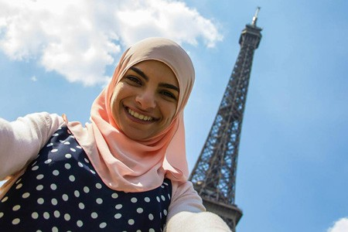Asil Moussa stands at the base of the Eiffel Tower. She was one of about a dozen creative writing students who traveled to France in early July.
Travelling this summer to the locations where some of modern literature’s most famous authors penned many of their greatest works was akin to a pilgrimage for some very fortunate creative writing students.
About a dozen students in Marty Gervais’ third-year creative writing class went to France in early July, spending a few days in Paris before heading off to a farm estate called La Roche D’Hys in the Auxois region of Burgundy, where they were the guests of Howard Aster.
“Marty and Howard know the literary background of Paris, so it was really cool to be with them,” said Asil Moussa, who is going into her third year of the digital journalism program. “Hemingway and Fitzgerald wrote all these great works there and Marty just wanted us to experience what they did. I use everything as inspiration, and he took us there to be inspired.”
Nestled between a rock escarpment and a valley of rolling hills and pastures, the farm house where the students stayed is an international professional development centre that hosts special projects to stimulate creative thinking.
Angelica Lachance, who is going into fourth year doing double major in English and psychology with a minor in history, said it was an enriching experience to be with like-minded people in such a beautiful setting. She had visited France on another occasion as a tourist, but said this was a totally different experience.
“I felt like we were living there,” Lachance said. “It was nice to be able to spend time with people who like and understand the things that matter to me.”
Students have the option of taking a third-year creative writing course during the regular academic year, or taking the 10-day trip with Gervais in the summer. The course starts in the weeks leading up to the trip when students are asked to readThat Summer in Paris by Morley Callaghan and Ernest Hemingway's A Moveable Feast.
When they get to France, the students attend workshops that examine the craft of writing and the experience of being in the country. These intersecting points of writing and culture are intended to make the experience vivid and rich for the students. They tour Paris, travel to nearby villages from the farmhouse, work on their photography, enjoy lengthy exquisite meals in the evening, and have nightly readings to showcase their creative efforts.
“I felt like the whole time my senses were going crazy,” said Moussa, who writes poetry, but is also in to photography and filmmaking. “There was so much to taste and hear and smell and see. You learn a lot of things about writing when you don’t even realize you’re learning them. But it’s not just writing and photography. It’s like a life course.”
Lachance said the nightly readings helped her overcome her reservations about sharing her creative work in public.
“Everyone brought a different perspective, so it forced me to re-evaluate my own work and the thought process that goes in to it,” said LaChance, who is considering a career in teaching.
For Moussa, the trip was an affirmation.
“I left France very sure that I can do whatever I set my mind to,” said Moussa, who wants to continue writing, creating films, and perhaps even hosting her own television talk show one day. “You just feel like you grew as a person.”

See video: https://youtu.be/jRTMgqzLiGU

